The SOC team discovered a suspiciously large log file after a recent breach. When they opened it, they found an enormous block of encoded text instead of typical logs. Could there be something hidden within? Your mission is to inspect the resulting file and reveal the real purpose of it. The team is relying on your skills to uncover any concealed information within this unusual log.
Download the encoded data here: Logs Data. Be prepared—the file is large, and examining it thoroughly is crucial .
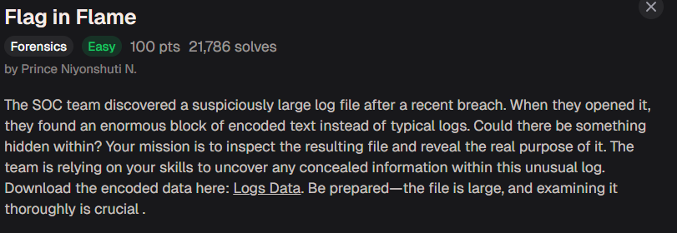
There is a hint. It shows “Use base64 to decode the data and generate the image file.”
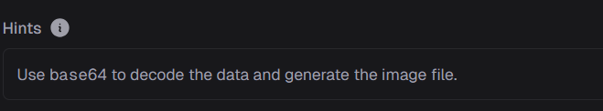
There is a Logs.txt file. Download and open it. There are a large amount base64 text inside.
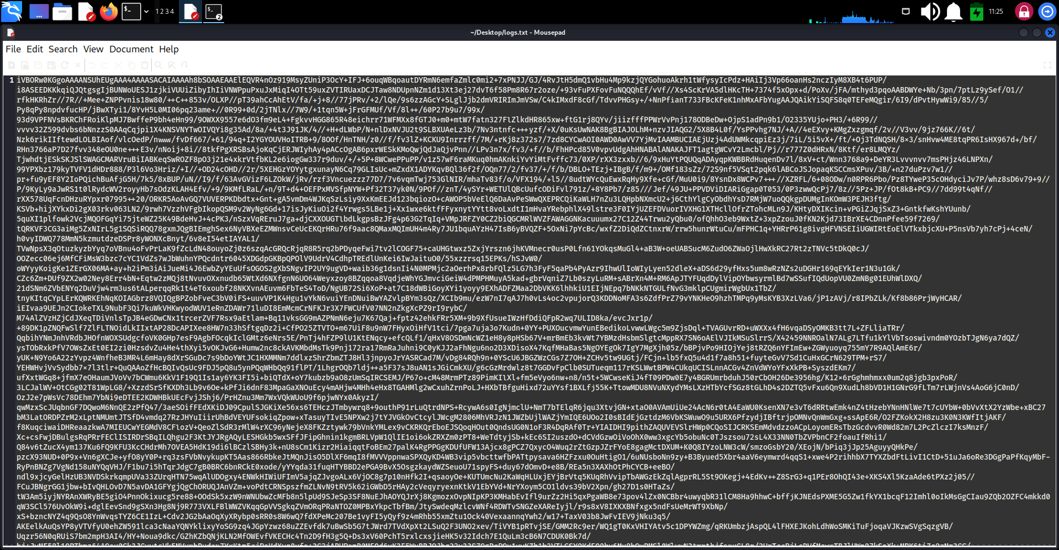
Using ‘cat’ to decode the base64 and transfer it to image.
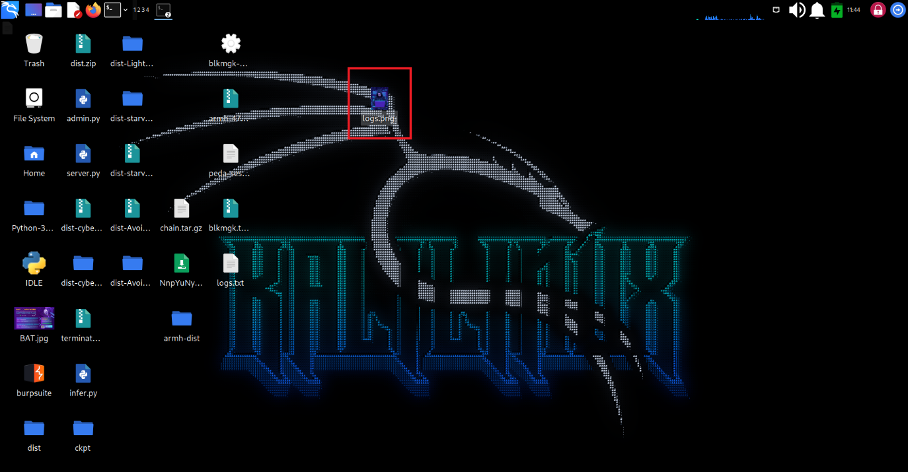
Open this image, we can get a value: 7069636F4354467B666F72656E736963735F616E616C797369735F69735F616D617A696E675F65633139383466637D
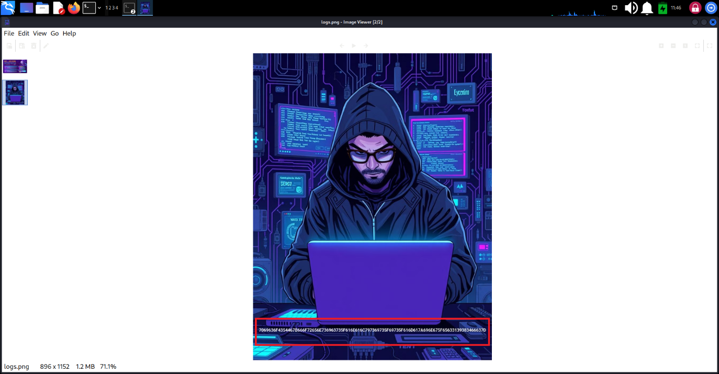
This value has uppercase and number 0-9. It might be hex encoded text. Using hex to decode it, we get the flag.
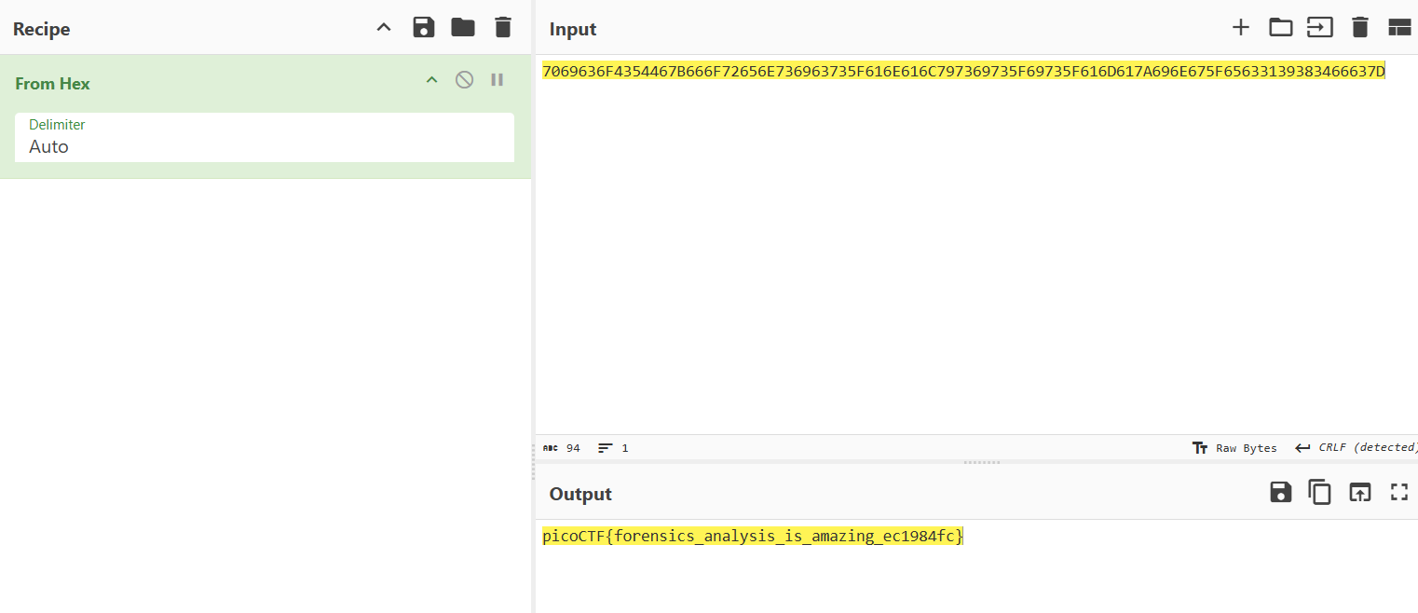
Flag: picoCTF{forensics_analysis_is_amazing_ec1984fc}

